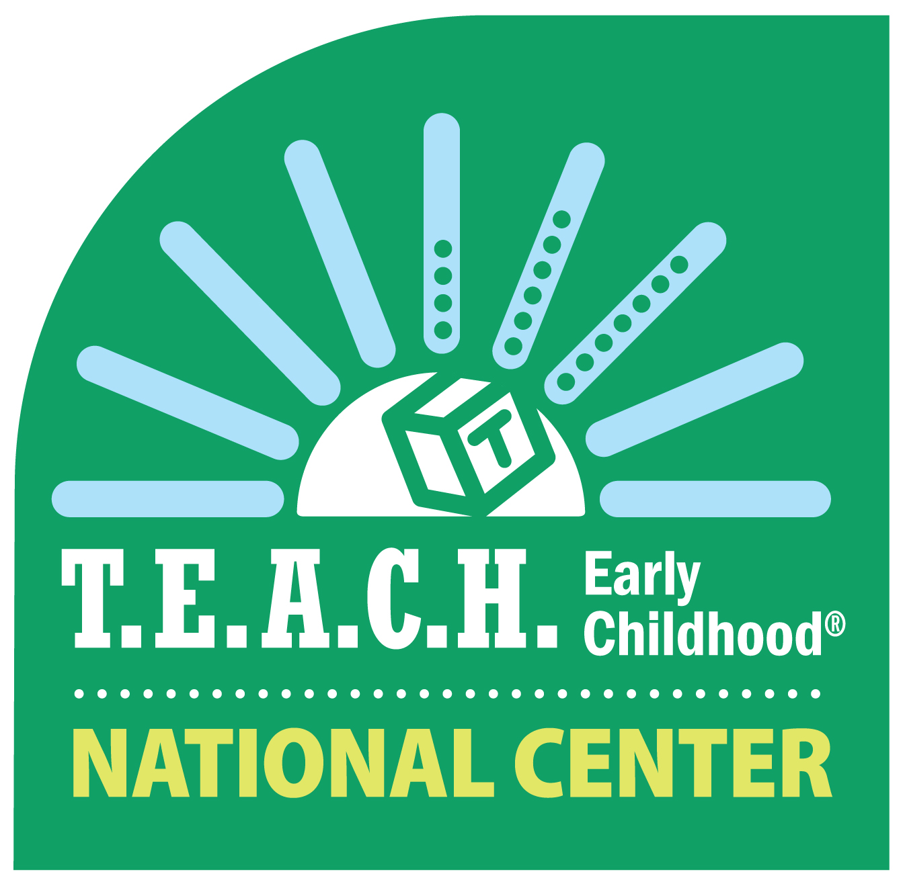
T.E.A.C.H. Early Childhood® and Child Care WAGE$®
2021 National Professional Development Virtual Symposium

Supporting the Essential Early Childhood Workforce
Behind the Workforce

April 27-29, 2021
Via Zoom

Request for Proposal – Deadline Extended

Now Due by Midnight, Friday, January 22, 2021

For 20 years, this Symposium has offered training and technical assistance on key topics related to the professional development of the early education workforce. We continue this focus in 2021, with the added dimensions of how the early childhood workforce has been and continues to be supported through the COVID-19 pandemic and how we ensure we are advancing equity in the profession.

The symposium provides an opportunity for staff of both T.E.A.C.H. Early Childhood® and Child Care WAGE$® Programs from across the country and other professionals committed to the education, compensation, retention and ongoing professional development of the early education workforce to update their knowledge, grow their skills and connect with colleagues.

In 2021 we will offer the symposium virtually, as we did this past spring. The Symposium includes 18 workshops across six breakout sessions, an opening keynote presentation the first morning, a plenary session on the second day, and a closing session on day three. Workshops are 75 minutes in length. Workshops are capped at 30 participants, providing a more intimate atmosphere for connecting in a virtual space. You can find out more about the Symposium here and review a copy of the 2020 Symposium program here.

Symposium participants typically include:
- T.E.A.C.H. and WAGE$ Program staff including program administrators, counselors, and administrative support staff. (Information on T.E.A.C.H. and WAGE$ can be viewed on our website. Click here for T.E.A.C.H. and here for WAGE$.
- Professionals supporting the continuing education of the early education workforce, including higher education faculty and state and national non-profit organization professionals.
- Partners working in or on behalf of early education systems including local, state and national governmental agency personnel, policy makers, funders and others working on professional development systems.

The 2021 National Symposium will be held April 27-29, virtually via Zoom.

CALL FOR PROPOSALS
The T.E.A.C.H. Early Childhood® National Center (Center) at Child Care Services Association (CCSA) is seeking workshop proposals of 75 minutes that address the many facets, strategies and supports needed to advance the professional development, compensation and retention levels of the early education workforce. We are also interested in workshops that address successful strategies toward equity of access to education and compensation for the workforce and ways in which COVID-19 has not only highlighted the essential role of early childhood during the pandemic, but has also propelled policy, strategy and funding toward support of the early childhood workforce and industry.

Workshop content should reflect and be supported by evidence or research and provide participants with information, resources and strategies that will make a positive difference in their professional practice. The theme for the 2021 symposium is Supporting the Essential Early Childhood Workforce Behind the Workforce.

Content Areas
Proposals are sought in one or more of the following areas with a focus on early care and education and early educator professional development, compensation and retention.

- Advocacy/Public Policy/Research/Leadership Focused on Early Childhood Education
- College Students, (demographics, completion/success, pipeline)
- T.E.A.C.H. and/or WAGE$ Program Staff Development (i.e., Administration, Management, Database, Skills Development for T.E.A.C.H. and WAGE$ Counseling Staff)
- Compensation
- Outreach
- Fund Development/Public Awareness
- Professional Development Systems (including QRIS)
- Higher Education Systems (quality, affordability, accessibility)
- Supporting and Retaining a Diverse Early Education Workforce For The Children and Families They Serve

RFP SUBMISSION - To submit one or more proposals:
- Complete the attached RFP form and workshop and presenter information.
- Email your submission to Judy Leinbach at judyl@teachecnationalcenter.org.

QUESTIONS - Contact Julie Rogers at julier@teachecnationalcenter.org or 850-566-0465 if you have any questions.

PROPOSAL ACCEPTANCE - Presenters will be notified of acceptance in late January.

In appreciation of presenter contributions to the Symposium, up to two presenters per workshop will receive a discounted registration to the Symposium. Registration includes workshops and keynote, plenary and closing sessions.

RFP TIPS
When completing the RFP, presenters should ensure that:
- The topic is relevant to the needs of T.E.A.C.H. and/or WAGE$ program staff, early childhood professionals working in or on behalf of professional development systems, or both.
- The topic addresses a current and relevant issue in early childhood and/or a specific topic relevant to T.E.A.C.H. and/or WAGE$ staff.
- The approach is consistent with adult learning principles, engages the audience and promotes implementation of practice.
- The presentation is not a promotion or endorsement of a commercial product or for-profit program.

T.E.A.C.H. Early Childhood® and Child Care WAGE$® 2021 Symposium Proposal Form

Presenter Information– The main presenter and first co-presenter will receive a discounted registration. All other presenters will pay full price.
MAIN Presenter Information – Discount Registration | FIRST Co-Presenter Information – Discount Registration
Name: | Name:
Position: | Position:
Organization: | Organization:
Address: | Address:
City: State: Zip: | City: State: Zip:
Is this a home or work address? | Is this a home or work address?
Contact Phone: | Contact Phone:
Email: | Email:

SECOND Co-Presenter Information – Full Registration | THIRD Co-Presenter Information – Full Registration
Name: | Name:
Position: | Position:
Organization: | Organization:
Address: | Address:
City: State: Zip: | City: State: Zip:
Is this a home or work address? | Is this a home or work address?
Contact Phone: | Contact Phone:
Email: | Email:
No more than 4 presenters per workshop.

Workshop Content Areas and Target Audience
Content Areas - Select Only 1  Please indicate the Content Area for which your workshop content is designed. | Target Audience  Please indicate the Target Audience(s) for your workshop.  Check all that apply.
Advocacy/Public Policy/Research/Leadership Focused on Early Childhood Education  College Students (demographics, completion/success, pipeline)  T.E.A.C.H. and/or WAGE$ Program Staff Development (i.e., Administration, Management, Database, Skills Development for T.E.A.C.H. and WAGE$ Counseling Staff)  Compensation  Outreach  Fund Development/Public Awareness  Professional Development Systems (i.e., QRIS, Pathways)  Higher Education Systems (quality, affordability, accessibility)  Supporting and Retaining a Diverse Early Education Workforce For The Children and Families They Serve | T.E.A.C.H. Early Childhood® Counselors  T.E.A.C.H. Administrators  T.E.A.C.H. Administrative Support Staff  All T.E.A.C.H. Staff  Child Care WAGE$® Counselors  Child Care WAGE$ Administrators  Child Care WAGE$ Administrative Support Staff  All WAGE$ Staff  Higher Education Faculty  Other Professionals  Policymakers, local, state and national  Professional Development or Technical Assistance Practitioners  All attendees

Workshop Information

1) Title (20 words or less please)

2) Workshop Description: This summary is used in the Symposium Program and must be no longer than 100 words. The T.E.A.C.H. Early Childhood® National Center reserves the right to edit workshop titles and descriptions that are accepted for presentation. Please use “action” statements that align with workshop outcomes to catch the attention of attendees; include powerful words that tell what they will learn; how they will learn it; and/or why it is relevant and applicable.

4) Learning Outcomes: Briefly describe the 3-4 outcomes of your workshop. Learning outcomes must be clear, specific, concise and measurable. Use words such as “increase knowledge,” “apply or analyze information,” “synthesize and evaluate information.”

5) Teaching Methods: What teaching methods will you use during your workshop? Some examples of teaching methods include: Lecture, visuals, video, audio, examples, instructions, and analogies.

6) Audience Engagement: Describe how you will engage the audience in discussion or activities during the workshop?

7) Presenter(s) Expertise: What education and/or experience do you have that qualifies you to conduct a workshop about this topic? (Limit 2000 characters)

8) Have you presented this topic/workshop previously? If so, please briefly describe when and where.

Presentation Set-up: Each workshop will be offered via Zoom.

Please email your proposal to Judy Leinbach at
judyl@teachecnationalcenter.org

Our Symposium would not be possible without the commitment from our partners who take time to support the professional development needs of our T.E.A.C.H. and WAGE$ staff and other professionals who work on early childhood workforce issues. We thank you.

